12/12/2015
Courtney Kessler
Mathematics Education
Classroom Philosophy
EDU 301

The first time I ever took the time to think about what classroom management means was in Dr. Lamb’s EDU 301 class. On the first day she had an opening prompt on the first PowerPoint slide that said, “What is classroom management?” I remember writing “how to successfully control a classroom.” Classroom management is not how to control a classroom but rather how to “constitute provisions and procedures necessary to establish and maintain an environment in which instruction and learning can occur” (Wong & Wong, 2014).
When I think about what classroom management will look like in my class I instantly think about respect for persons. As Jim Fay says throughout Creating a Love and Logic School Culture, I will enforce that students treat me with the same respect as I treat them (Fay & Funk, 1995). I truly believe that students and teachers should be respected, one in the same. I expect the students to not only respect me but also their peers. This theme of respect will be my one and only rule in my classroom.
I plan to have a Love and Logic classroom. I aim to use the Love and Logic principles on a daily basis. Besides enforcing respect for persons, I want to share the control, share the thinking, and use the empathy/consequence formula. In order for the empathy/consequence strategy to be effective I will strive to make connections with all of my students and hopefully build relationships. “Relationships form the foundation of teaching” (Fay & Funk, 1995, ix). I want my classroom to be a comfortable, stable, good learning environment for my students and building good relationships will help create that environment. Also, these relationships will allow for me to get to know my students and know their interests. If I can spark their interest’s, then I can get them engaged in my classroom (Marzano & Pickering, 2003). For me, the idea of strong relationships will make or break my effectiveness as a teacher. If I fail to make strong relationships, I will not be doing my job to the best of my ability.
Overall, my classroom will have one rule and my teaching career will be built on one thing. My rule, as stated previously, is that the students are to treat me and their peers with the same respect as I treat them. My career will be built on relationships. I strongly believe that a classroom without respect and relationships is a recipe for disaster.
The Classroom Procedures I have listed below will be expressed during the first class period of the year/semester. The class will go over the syllabus together and all procedures plus my one rule will be included in the syllabus.
The pictures on page 5 are example pictures of the posters that will be hung in my classroom. Daily, I will have the date, a quote, and Bell Work ready for each class period on the board (like the picture provide). I will also have the agenda for the week posted on the board (like the picture provided). The weekly agenda will show assignment due-dates for that week, test days, and a brief explanation of what is to be expected each day of the week for that class. I will also have the following posted in my classroom:
- I expect you to treat me and your peers with the same respect as I treat you.
- Feel free to do anything that doesn’t cause a problem for anyone else.
- If you cause a problem, I will ask you to solve it.
- If you can’t solve the problem, or choose not to, I will do something.
- What I do will depend on the special person and the special situation.
- If you feel something is unfair, we can talk about it after class.
(Fay & Funk, 1995, 46)
On the sixth page is a diagram of how I will have my classroom organized. However, there will be no assigned seating unless necessary.
CLASSROOM PROCEDURES

Beginning of Class:
- Enter quietly and find seat.
- Get out all materials.
- Start the Bell Work.

End of Class:
- Wait until Ms. Kessler dismisses you to put your materials away.
- Stay seated until bell rings.

Tardy:
- A student is tardy if they are not in the classroom when the bell rings.
- If tardy, go directly to seat and start Bell Work.

Bathroom Passes:
- Each student is given 5 bathroom passes a semester.
- If student needs to use the bathroom, he/she can use a pass.
- If a student has all 5 passes left at the end of the semester, he/she will receive 5 bonus points on the midterm/final.
- Likewise, if a student has no passes left at the end of the semester, he/she will not receive any bonus points.
- Also, if a student has used all of his/her passes and the semester is not over, he/she will not be allowed to go to the bathroom unless of an emergency.

Seating Charts:
- There will not be a seating chart in my classroom.
- However, if students need to be separated, I will do so.
- If the class gets completely out of hand, a seating chart will be implemented.

Homework:
- Homework will be assigned on Mondays and due on Fridays.
- Late homework will be docked 10% for every day it is late.
  - Weekends count as one day.
- If a student does not turn in an assignment, he/she will be expected to come in after school to work on it.

Grading:
- 75% of grade will come from assessment (quizzes, tests, projects, etc.)
- 20% of grade will come from homework
- 5% of grade will come from professionalism in the classroom (classroom behavior)

Absences:
- If a student is absent, he/she is expected to get the notes from another student.
- He/she can pick up any material that was handed out in the “Absent Bin”

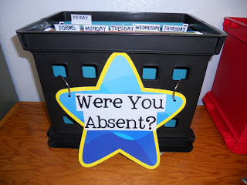

CLASSROOM POSTERS
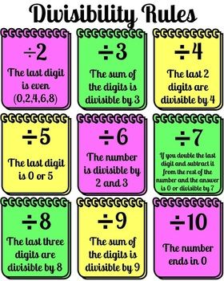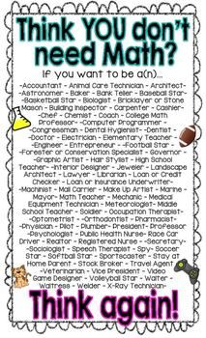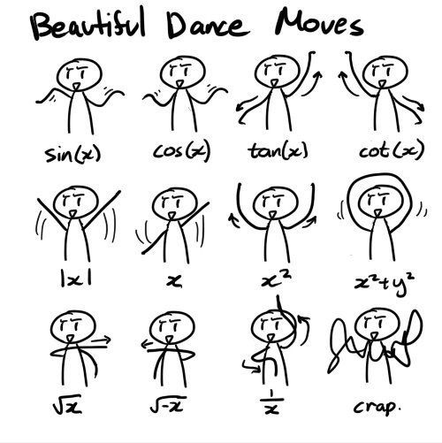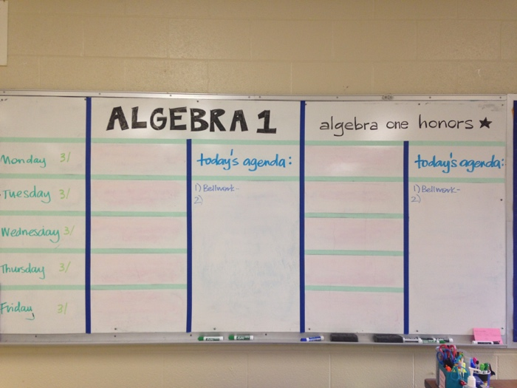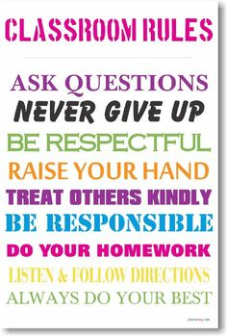
SEATING CHART:

Front of the Classroom
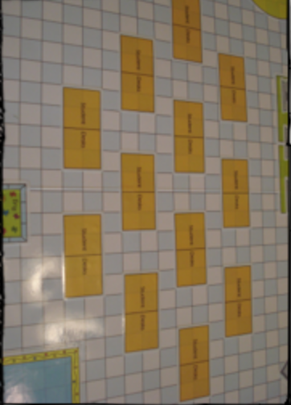
Each yellow square represents one desk. So students are in pods of two.
References

Fay, J. & Funk, D. (1995). Teaching with Love & Logic: Taking control of the classroom. Love & Logic Press Inc: Golden, CO.
Marzano, R. J. & Pickering, D. J. (2003). Classroom Management that Works: Research –based strategies for every teacher. ASCD Press: Alexandria, VA.
Wong, H., & Wong, R. (2014). The Classroom Management Book. Harry K. Wong Publications, Inc: Mountain View, CA.

Picture Citations

Absent Bin
https://www.pinterest.com/pin/403775922814214765/
Division Sign
https://www.pinterest.com/pin/155374255871208825/
Think You Don’t Need Math
https://www.pinterest.com/pin/286400857526799292/
Dance Move
http://fromamathclass.blogspot.com/2012_07_01_archive.html
Inspire
http://inspirational-classroom-posters.webnode.com
Daily Agenda
https://sonatamathematique.wordpress.com/2015/03/18/organization/
Classroom Rules
http://www.amazon.com/Classroom-Rules-NEW-Motivational-Poster/dp/B00DZRB0PE
Seating Arrangement
http://www.classroomdeskarrangement.com/ClassroomDeskArrangement/Space_Invaders.html

